DOMINE:APPLIED DATA SCIENCE
PROJECT TITLE:CREDIT CARD FRAUD DETECTION
TEAM MEMBERS:
S.KUMARESAN
N.RAVIVARMA
E.VIKRAM
B.AJITHKUMAR
PHASE 5 : Project Documentation & Submission
PROJECT : CREDIT CARD FRAUD DETECTION
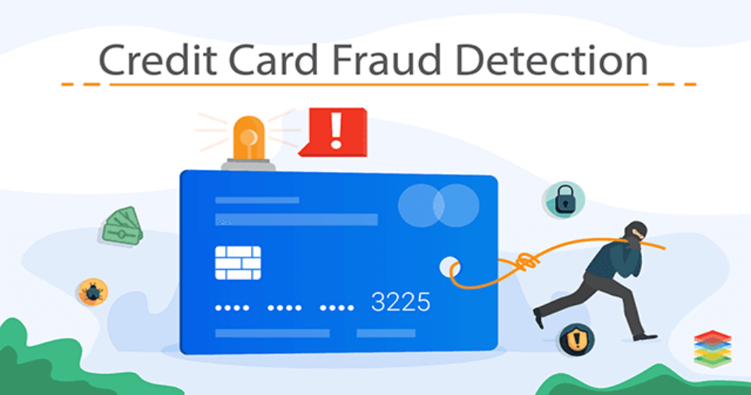

INTRODUCTION :
In the realm of digital transactions, credit card fraud poses a significant threat to both consumers and businesses. Detecting and preventing fraudulent activities swiftly and accurately is paramount. This project dives into the world of Credit Card Fraud Detection, employing advanced algorithms and data analytics to identify suspicious patterns and transactions. By leveraging cutting-edge technology, this project experience for all.
PROBLEM DEFINITION:
The problem is to develop a machine learning-based system for real-time credit card fraud detection. The goal is to create a solution that can accurately identify fraudulent transactions while minimizing false positives. This project involves data preprocessing, feature engineering, model selection, training, and evaluation to create a robust fraud detection system.Data preprocessing is an important step in the data mining process. It refers to the cleaning, transforming, and integrating of data in order to make it ready for analysis. The goal of data preprocessing is to improve the quality of the data and to make it more suitable for the specific data mining task.Feature engineering involves a set of techniques that enable us to create new features by combining or transforming the existing ones. These techniques help to highlight the most important patterns and relationships in the data, which in turn helps the machine learning model to learn from the data more effectively.In its most basic forms, model selection is one of the fundamental tasks of scientific inquiry. Determining the principle that explains a series of observations is often linked directly to a mathematical model predicting those observations. For example, when Galileo performed his inclined plane experiments, he demonstrated that the motion of the balls fitted the parabola predicted by his model.
DESIGN THINKING:
DATA SOURCE :

A data source refers to a place or system from which you obtain data or information. Data sources can vary widely, and they can be physical or digital. Here are some common types of data sources.
Step-1:
TRANSACTION DATASET:
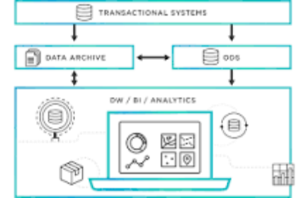
Transactional data is information that is captured from transactions. It records the time of the transaction, the place where it occurred, the price points of the items bought, the payment method employed, discounts if any, and other quantities and qualities associated with the transaction.
Step-2:
TRANSACTION AMOUNT:


A data source is the location where data that is being used originates from. A data source may be the initial location where data is born or where physical information is first digitized, however even the most refined data may serve as a source, as long as another process accesses and utilizes it.
Step-3:
TIMESTAM:
SQL Server timestamps are a data type used to store a date and time value. The timestamp data type stores a date and time value in the format YYYY-MM-DD HH:MM:SS. The timestamp data type is an 8-byte value representing a date and time value in the YYYY-MM-DD HH:MM:SS format.
Step-4:
MERCHANT INFORMATION:
The details about your products that you submit to the Google Merchant Centre. Your product data is used to show dynamic ads, free product listings and Shopping ads when you run a Google Ads campaign.
Step-5:
CARD DETAILS:
Ultimately, data sources are intended to help users and applications connect to and move data to where it needs to be. They gather relevant technical information in one place and hide it so data consumers can focus on processing and identify how to best utilize their data.

DATASET LINK : (www.Kaggle.com/data)
PROGRAM :
import numpy as np
import pandas as pd
import matplotlib.pyplot as plt
import seaborn as sns
from sklearn.utils import resample
from sklearn.preprocessing import StandardScaler
from sklearn.model_selection import train_test_split
from sklearn.svm import SVC
from sklearn.metrics import f1_score, precision_score, accuracy_score

DATA PREPROCESSING:
Data preprocessing is a crucial step in the data analysis pipeline. It involves cleaning, transforming, and organizing raw data into a format suitable for analysis. Proper data preprocessing helps ensure that your data is accurate, consistent, and ready for modeling or other analytical tasks. Here are some common data preprocessing tasks.
Step-1:
PREPROCESS THE DATA:
Ultimately, data sources are intended to help users and applications connect to and move data to where it needs to be. They gather relevant technical information in one place and hide it so data consumers can focus on processing and identify how to best utilize their data. information in one place.
Step-2:
HANDEL MISSING VALUES:rs can focus on p
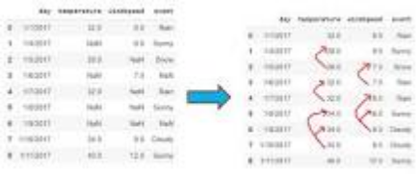
the deletion of the rows or columns having null values. If any columns have more than half of the values as null then you can drop the entire column. In the same way, rows can also be dropped if having one or more columns values as null.utilize their data.
Step-3:
NORMAIZE FEATURES:
Normalization is a data preprocessing technique used to transform features in a dataset to a common scale, improving the performance and accuracy of machine learning algorithms. The main goal of normalization is to eliminate the potential biases and distortions caused by the different scales of features.
FEATURE ENGINEERING :
Feature engineering is a critical and creative process in machine learning and data analysis. It involves creating new features or transforming existing ones to improve the performance of a predictive model or to gain better insights from data. Feature engineering can have a significant impact on the success of your machine learning project. Here are some key aspects of feature engineering.
Step-1:
ENHANCE FRAUDE DETECTION :

Feature engineering is the key to success in modeling. Good feature engineering can capture the nature of the problem, thus rendering a better outcome. What is a feature? A feature is a variable that describes the latent patterns. In this article, I will survey feature engineering in the literature on credit card fraud. Readers will learn how other data scientists create features to attach fraud in different industries. In Feature Engineering for Healthcare Fraud Detection, I show you how to create features for the healthcare industry.
Step-2:
TRANSACTION FREQUENCY:
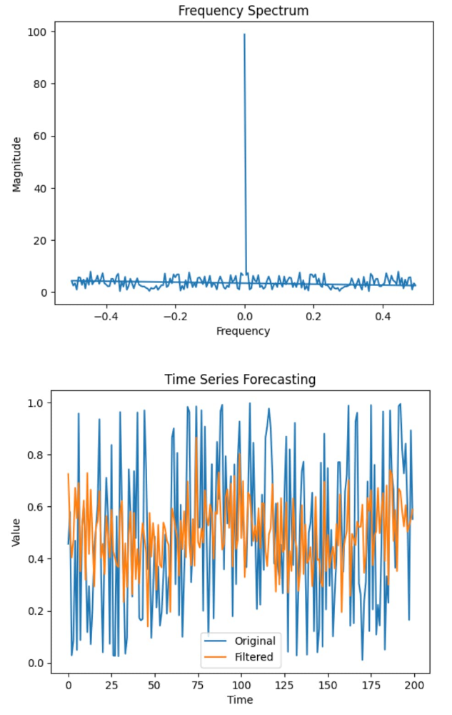
In this blog post, I would like to focus on feature engineering to predict customer transactions for the next month. As a data scientist working in marketing, I find it quite important to understand why I am doing some work and how it can solve a business problem. I think feature engineering is a part of an analysis where the domain knowledge and hard skills are equally important and blended to find a better solution to a problem.
Step-3:
AMOUNT DEVIATIONS:
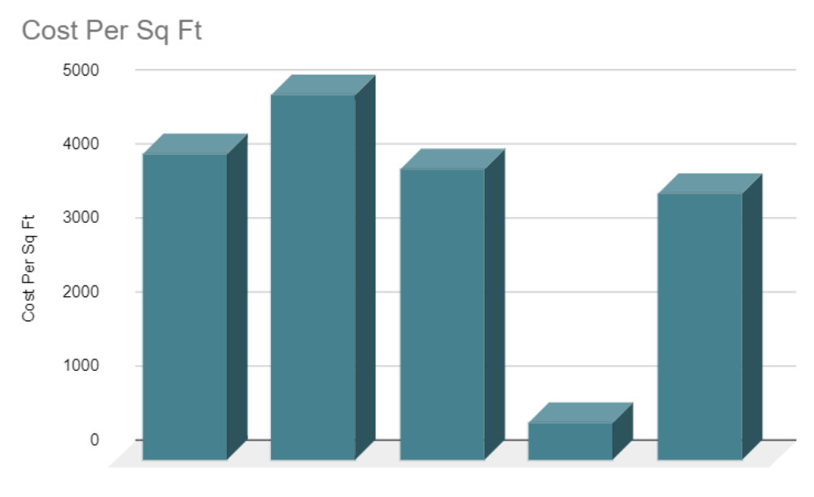
When you plot the data, youll notice that one price is significantly different from the rest. In the visualisation method, you can readily notice the problem. The third way is to use Statistics to analyze your data and find any problem. Feature engineering consists of various process.
MODEL SELECTION:
Model selection is a critical step in the machine learning workflow. It involves choosing the most appropriate machine learning algorithm or model for a specific task. The right choice of model can significantly impact the performance and success of your machine learning project. Here are some key considerations and steps in model selection
OUT:
Best Model: Random Forest
Classification Report on Test Set:
precision recall f1-score support
0 0.99 1.00 0.99 56864
1 0.97 0.75 0.85 98

accuracy 0.99 56962
macro avg 0.98 0.87 0.92 56962
weighted avg 0.99 0.99 0.99 56962
Step-1:
MACHINE LEARNING ALGORITHMS FOR FRAUD DETECTION:
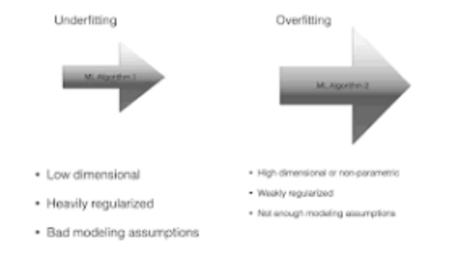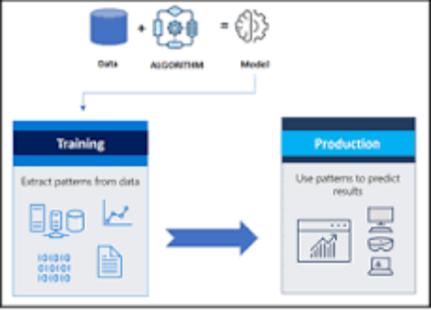
Model selection is the process of deciding which algorithm and model architecture is best suited for a particular task or dataset. It entails contrasting various models, assessing their efficacy, and choosing the one that most effectively addresses the issue at hand.
Step-2:
e.g.
Logistic Regression:
select all the variables whose p-value < 0.25 along with the variables of known clinical importance. Step 2: Fit a multiple logistic regression model using the variables selected in step 1. Verify the importance of each variable in this multiple model using Wald statistic.

MODEL TRAINING :
Model training is a crucial step in the process of building machine learning models. It involves using a dataset to teach a machine learning algorithm or model to make predictions or classify data. Here are the key steps and concepts involved in model training.
OUT :
SVC
SVC(kernel='linear')

Step-1:
TRAIN THE SELECTED MODEL USING THE PREPROCESSED DATA:
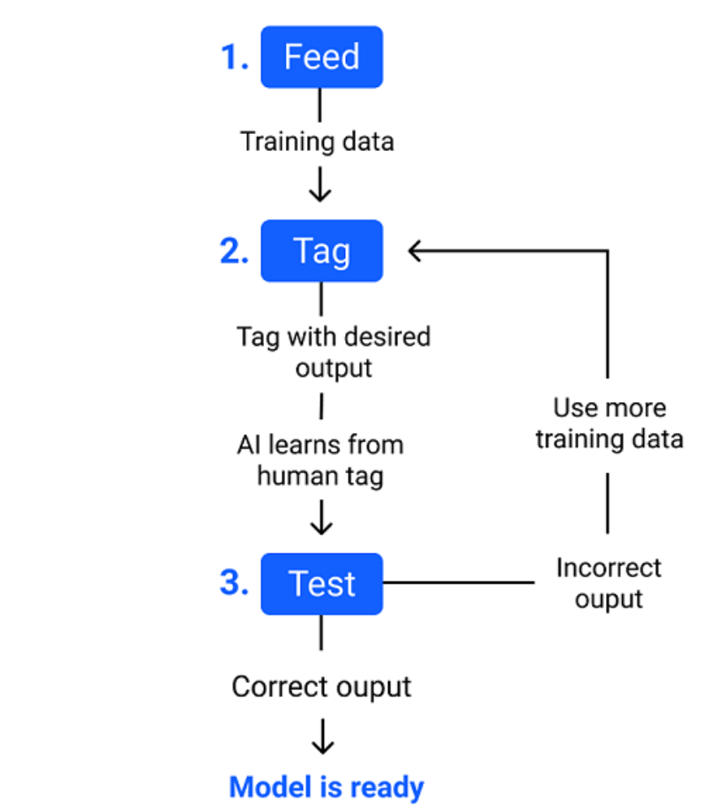

The main difference between training data and testing data is that training data is the subset of original data that is used to train the machine learning model, whereas testing data is used to check the accuracy of the model. The training dataset is generally larger in size compared to the testing dataset.
MODEL EVALUATION :
Model evaluation is a critical step in the machine learning workflow, as it helps you assess how well your trained model performs and whether it is suitable for the intended task. Proper model evaluation ensures that your model can make reliable predictions and generalizes well to unseen data. Here are the key concepts and techniques involved in model evaluation.

OUT:
The accuracy score is: 0.95
The precision score is: 0.88
The F1 score is: 0.91
Ste-1:
EVALUATE THE MODEL'S PERFORMANCE USING MATRICS LIKE ACCURANCY:
Therefore evaluating a model plays a vital role so that we can judge the performance of our model. The evaluation also helps to analyze a model's key weaknesses. There are many metrics like Accuracy, Precision, Recall, F1 score, Area under Curve, Confusion Matrix, and Mean Square Error.What is the evaluation metrics for accuracy?
Accuracy means that how many data points are predicted correctly. It is one of the simplest form of evaluation metrics. The accuracy score is # of correct points / # total = (30 + 35 + 50) / 200 = 0.575.
Step-2:
PRECISION:
Precision evaluates how precise a model is in predicting positive labels. Precision answers the question, out of the number of times a model predicted positive, how often was it correct? Precision is the percentage of your results which are relevant.
Step-3:
RECALL:
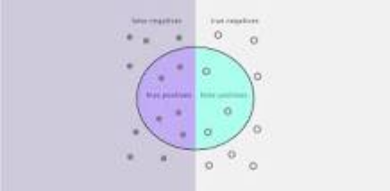

Recall in this context is defined as the number of true positives divided by the total number of elements that actually belong to the positive class (i.e. the sum of true positives and false negatives, which are items which were not labelled as belonging to the positive class but should have been).
Step-4:
F1-score :
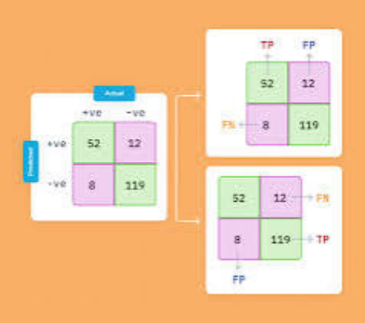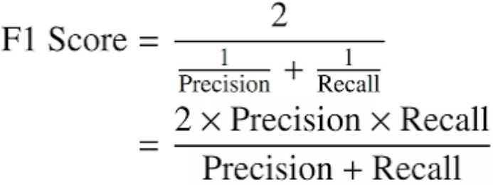
F1-score is the evaluation matrix that combines two matrices: Precision and Recall, into a single metric by taking their harmonic mean. In simple terms, the f1 score is the weighted average mean of Precision and Recall. It is also used in Natural Language Processing.
Step-5:
ROC-AUC:
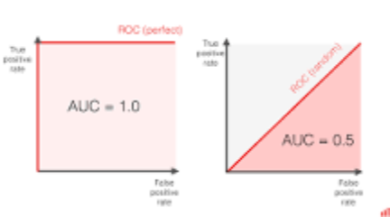

To get the score, you must measure the area under the ROC curve. ROC AUC score shows how well the classifier distinguishes positive and negative classes. It can take values from 0 to 1. A higher ROC AUC indicates better performance.
IN:1
import numpy as np
import pandas as pd
import sklearn
import scipy
import matplotlib.pyplot as plt
import seaborn as sns
from sklearn.metrics import classification_report,accuracy_score
from sklearn.ensemble import IsolationForest
from sklearn.neighbors import LocalOutlierFactor
from sklearn.svm import OneClassSVM
from pylab import rcParams
rcParams['figure.figsize'] = 14, 8
RANDOM_SEED = 42
LABELS = ["Normal", "Fraud"]
#import plotly.plotly as py
import plotly.graph_objs as go
import plotly
import plotly.figure_factory as ff
from plotly.offline import init_notebook_mode, iplot
IN:2
data =pd.read_csv ('/kaggle/input/creditcardfraud/creditcard.csv')
data.head()
OUT:2
Time V1 V2 V3 V4 V5 V6 V7 V8 V9 ... V21 V22 V23 V24 V25 V26 V27 V28 Amount Class
0 0.0 -1.359807 -0.072781 2.536347 1.378155 -0.338321 0.462388 0.239599 0.098698 0.363787 ... -0.018307 0.277838 -0.110474 0.066928 0.128539 -0.189115 0.133558 -0.021053 149.62 0
1 0.0 1.191857 0.266151 0.166480 0.448154 0.060018 -0.082361 -0.078803 0.085102 -0.255425 ... -0.225775 -0.638672 0.101288 -0.339846 0.167170 0.125895 -0.008983 0.014724 2.69 0
2 1.0 -1.358354 -1.340163 1.773209 0.379780 -0.503198 1.800499 0.791461 0.247676 -1.514654 ... 0.247998 0.771679 0.909412 -0.689281 -0.327642 -0.139097 -0.055353 -0.059752 378.66 0
3 1.0 -0.966272 -0.185226 1.792993 -0.863291 -0.010309 1.247203 0.237609 0.377436 -1.387024 ... -0.108300 0.005274 -0.190321 -1.175575 0.647376 -0.221929 0.062723 0.061458 123.50 0
4 2.0 -1.158233 0.877737 1.548718 0.403034 -0.407193 0.095921 0.592941 -0.270533 0.817739 ... -0.009431 0.798278 -0.137458 0.141267 -0.206010 0.502292 0.219422 0.215153 69.99 0
5 rows × 31 columns
IN:3
data1= data.sample(frac = 0.1,random_state=1)
data1.shape
OUT:3
(28481, 31)
IN:4
data.isnull().sum()
OUT:4
Time 0
V1 0
V2 0
V3 0
V4 0
V5 0
V6 0
V7 0
V8 0
V9 0
V10 0
V11 0
V12 0
V13 0
V14 0
V15 0
V16 0
V17 0
V18 0
V19 0
V20 0
V21 0
V22 0
V23 0
V24 0
V25 0
V26 0
V27 0
V28 0
Amount 0
Class 0
dtype: int64
IN:5
data.describe()
OUT:5
Time V1 V2 V3 V4 V5 V6 V7 V8 V9 ... V21 V22 V23 V24 V25 V26 V27 V28 Amount Class
count 284807.000000 2.848070e+05 2.848070e+05 2.848070e+05 2.848070e+05 2.848070e+05 2.848070e+05 2.848070e+05 2.848070e+05 2.848070e+05 ... 2.848070e+05 2.848070e+05 2.848070e+05 2.848070e+05 2.848070e+05 2.848070e+05 2.848070e+05 2.848070e+05 284807.000000 284807.000000
mean 94813.859575 1.168375e-15 3.416908e-16 -1.379537e-15 2.074095e-15 9.604066e-16 1.487313e-15 -5.556467e-16 1.213481e-16 -2.406331e-15 ... 1.654067e-16 -3.568593e-16 2.578648e-16 4.473266e-15 5.340915e-16 1.683437e-15 -3.660091e-16 -1.227390e-16 88.349619 0.001727
std 47488.145955 1.958696e+00 1.651309e+00 1.516255e+00 1.415869e+00 1.380247e+00 1.332271e+00 1.237094e+00 1.194353e+00 1.098632e+00 ... 7.345240e-01 7.257016e-01 6.244603e-01 6.056471e-01 5.212781e-01 4.822270e-01 4.036325e-01 3.300833e-01 250.120109 0.041527
min 0.000000 -5.640751e+01 -7.271573e+01 -4.832559e+01 -5.683171e+00 -1.137433e+02 -2.616051e+01 -4.355724e+01 -7.321672e+01 -1.343407e+01 ... -3.483038e+01 -1.093314e+01 -4.480774e+01 -2.836627e+00 -1.029540e+01 -2.604551e+00 -2.256568e+01 -1.543008e+01 0.000000 0.000000
25% 54201.500000 -9.203734e-01 -5.985499e-01 -8.903648e-01 -8.486401e-01 -6.915971e-01 -7.682956e-01 -5.540759e-01 -2.086297e-01 -6.430976e-01 ... -2.283949e-01 -5.423504e-01 -1.618463e-01 -3.545861e-01 -3.171451e-01 -3.269839e-01 -7.083953e-02 -5.295979e-02 5.600000 0.000000
50% 84692.000000 1.810880e-02 6.548556e-02 1.798463e-01 -1.984653e-02 -5.433583e-02 -2.741871e-01 4.010308e-02 2.235804e-02 -5.142873e-02 ... -2.945017e-02 6.781943e-03 -1.119293e-02 4.097606e-02 1.659350e-02 -5.213911e-02 1.342146e-03 1.124383e-02 22.000000 0.000000
75% 139320.500000 1.315642e+00 8.037239e-01 1.027196e+00 7.433413e-01 6.119264e-01 3.985649e-01 5.704361e-01 3.273459e-01 5.971390e-01 ... 1.863772e-01 5.285536e-01 1.476421e-01 4.395266e-01 3.507156e-01 2.409522e-01 9.104512e-02 7.827995e-02 77.165000 0.000000
max 172792.000000 2.454930e+00 2.205773e+01 9.382558e+00 1.687534e+01 3.480167e+01 7.330163e+01 1.205895e+02 2.000721e+01 1.559499e+01 ... 2.720284e+01 1.050309e+01 2.252841e+01 4.584549e+00 7.519589e+00 3.517346e+00 3.161220e+01 3.384781e+01 25691.160000 1.000000
8 rows × 31 columns
IN:6
count_classes = pd.value_counts(data['Class'], sort = True)
count_classes.plot(kind = 'bar', rot=0)
plt.title("Transaction Class Distribution")
plt.xticks(range(2), LABELS)
plt.xlabel("Class")
plt.ylabel("Frequency");
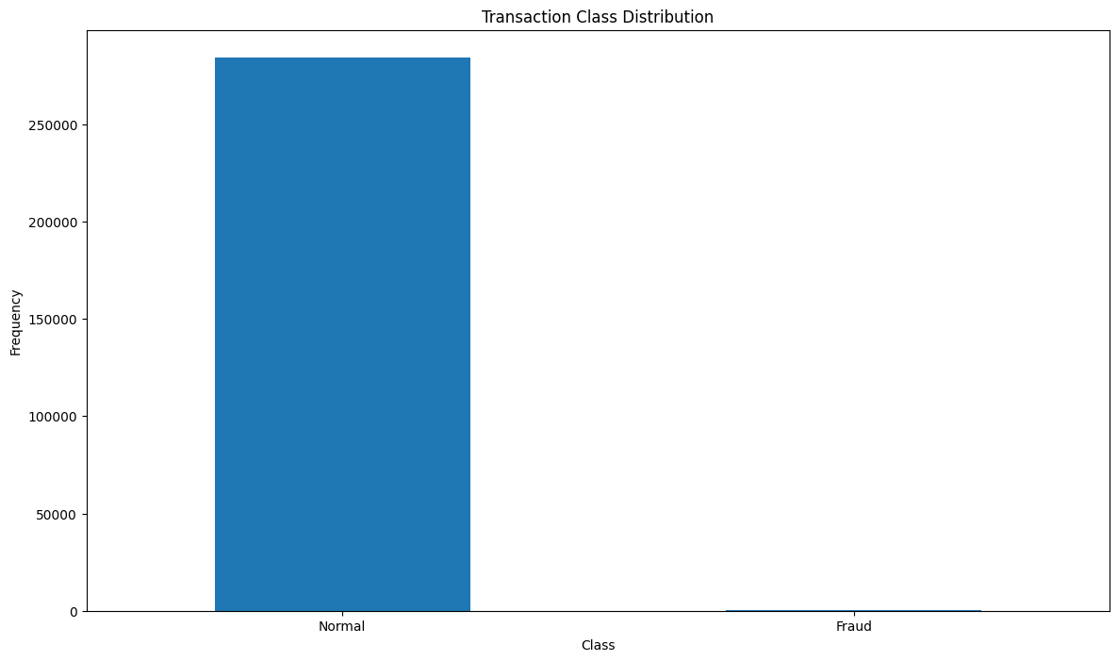
IN:7
Normal = data[data['Class']==0]
Fraud = data[data['Class']==1]
Normal.shape
OUT:7
(284315, 31)
IN:8
Fraud.shape
OUT:8
(492, 31)
IN:9
Normal.Amount.describe()
OUT:9
count 284315.000000
mean 88.291022
std 250.105092
min 0.000000
25% 5.650000
50% 22.000000
75% 77.050000
max 25691.160000
Name: Amount, dtype: float64
IN:10
Fraud.Amount.describe()
OUT:10
count 492.000000
mean 122.211321
std 256.683288
min 0.000000
25% 1.000000
50% 9.250000
75% 105.890000
max 2125.870000
Name: Amount, dtype: float64
IN:11
f, (ax1, ax2) = plt.subplots(2, 1, sharex=True)
f.suptitle('Amount per transaction by class')
bins = 50
ax1.hist(Fraud.Amount, bins = bins)
ax1.set_title('Fraud')
ax2.hist(Normal.Amount, bins = bins)
ax2.set_title('Normal')
plt.xlabel('Amount ($)')
plt.ylabel('Number of Transactions')
plt.xlim((0, 20000))
plt.yscale('log')
plt.show();
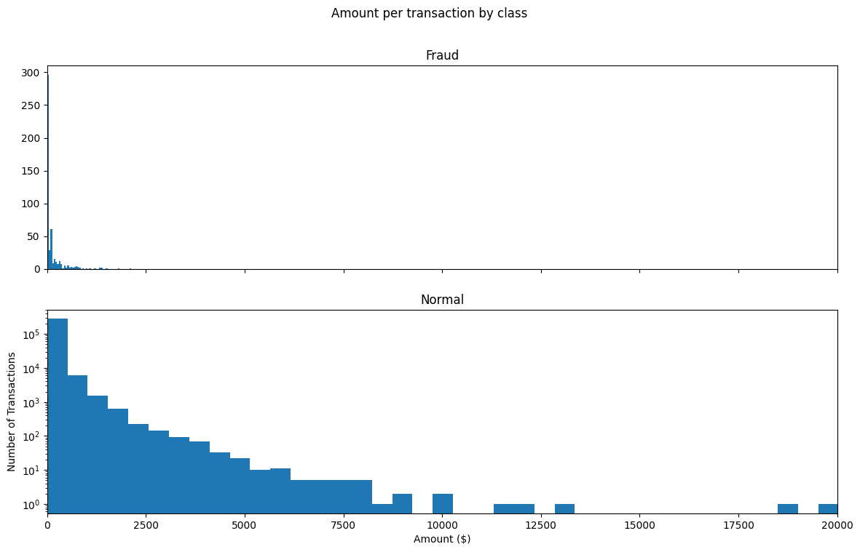
IN:12
f, (ax1, ax2) = plt.subplots(2, 1, sharex=True)
f.suptitle('Time of transaction vs Amount by class')
ax1.scatter(Fraud.Time, Fraud.Amount)
ax1.set_title('Fraud')
ax2.scatter(Normal.Time, Normal.Amount)
ax2.set_title('Normal')
plt.xlabel('Time (in Seconds)')
plt.ylabel('Amount')
plt.show();
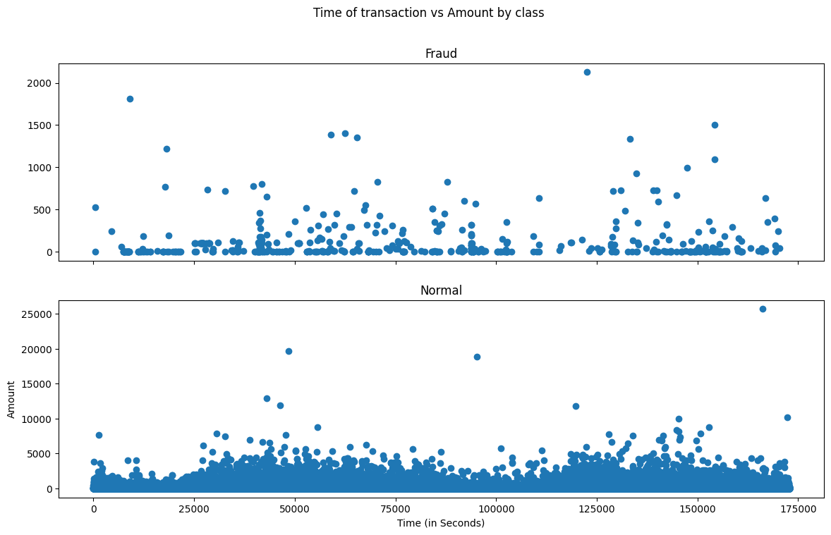
IN:13
init_notebook_mode(connected=True)
plotly.offline.init_notebook_mode(connected=True)
IN:14
trace = go.Scatter(
x = Fraud.Time,
y = Fraud.Amount,
mode = 'markers'
)
data = [trace]

plotly.offline.iplot({
"data": data
})
IN:15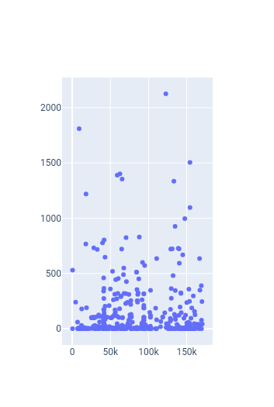
Fraud = data1[data1['Class']==1]
Valid = data1[data1['Class']==0]
outlier_fraction = len(Fraud)/float(len(Valid))
print(outlier_fraction)
print("Fraud Cases : {}".format(len(Fraud)))
print("Valid Cases : {}".format(len(Valid)))
0.0017234102419808666
Fraud Cases : 49
Valid Cases : 28432
IN:16
correlation_matrix = data1.corr()
fig = plt.figure(figsize=(12,9))
sns.heatmap(correlation_matrix,vmax=0.8,square = True)
plt.show()
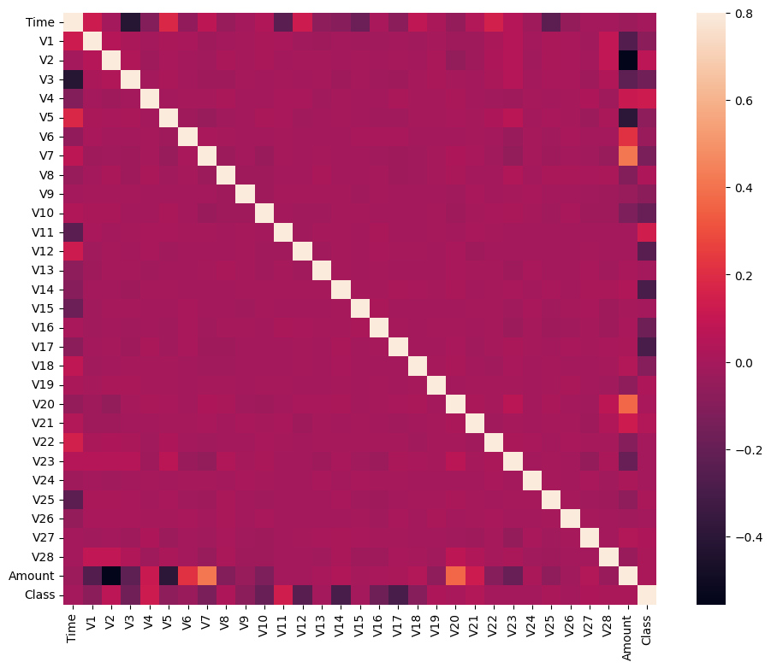
IN:17
columns = data1.columns.tolist()
# Filter the columns to remove data we do not want
columns = [c for c in columns if c not in ["Class"]]
# Store the variable we are predicting
target = "Class"
# Define a random state
state = np.random.RandomState(42)
X = data1[columns]
Y = data1[target]
X_outliers = state.uniform(low=0, high=1, size=(X.shape[0], X.shape[1]))
# Print the shapes of X & Y
print(X.shape)
print(Y.shape)
(28481, 30)
(28481,)
IN:18
classifiers = {
"Isolation Forest":IsolationForest(n_estimators=100, max_samples=len(X),
contamination=outlier_fraction,random_state=state, verbose=0),
"Local Outlier Factor":LocalOutlierFactor(n_neighbors=20, algorithm='auto',
leaf_size=30, metric='minkowski',
p=2, metric_params=None, contamination=outlier_fraction),
"Support Vector Machine":OneClassSVM(kernel='rbf', degree=3, gamma=0.1,nu=0.05,
max_iter=-1)

}
IN:19
n_outliers = len(Fraud)
for i, (clf_name,clf) in enumerate(classifiers.items()):
#Fit the data and tag outliers
if clf_name == "Local Outlier Factor":
y_pred = clf.fit_predict(X)
scores_prediction = clf.negative_outlier_factor_
elif clf_name == "Support Vector Machine":
clf.fit(X)
y_pred = clf.predict(X)
else:
clf.fit(X)
scores_prediction = clf.decision_function(X)
y_pred = clf.predict(X)
#Reshape the prediction values to 0 for Valid transactions , 1 for Fraud transactions
y_pred[y_pred == 1] = 0
y_pred[y_pred == -1] = 1
n_errors = (y_pred != Y).sum()
# Run Classification Metrics
print("{}: {}".format(clf_name,n_errors))
print("Accuracy Score :")
print(accuracy_score(Y,y_pred))
print("Classification Report :")
print(classification_report(Y,y_pred))
/opt/conda/lib/python3.10/site-packages/sklearn/base.py:439: UserWarning:

X does not have valid feature names, but IsolationForest was fitted with feature names

Isolation Forest: 73
Accuracy Score :
0.9974368877497279
Classification Report :
precision recall f1-score support

0 1.00 1.00 1.00 28432
1 0.26 0.27 0.26 49

accuracy 1.00 28481
macro avg 0.63 0.63 0.63 28481
weighted avg 1.00 1.00 1.00 28481

Local Outlier Factor: 97
Accuracy Score :
0.9965942207085425
Classification Report :
precision recall f1-score support

0 1.00 1.00 1.00 28432
1 0.02 0.02 0.02 49

accuracy 1.00 28481
macro avg 0.51 0.51 0.51 28481
weighted avg 1.00 1.00 1.00 28481

Support Vector Machine: 8516
Accuracy Score :
0.7009936448860644
Classification Report :
precision recall f1-score support

0 1.00 0.70 0.82 28432
1 0.00 0.37 0.00 49

accuracy 0.70 28481
macro avg 0.50 0.53 0.41 28481
weighted avg 1.00 0.70 0.82 28481

